FINLAND – WELCOME TO THE HOME OF SANTA CLAUS

Looking for space, fresh air, stimulating cultural events and exciting activities? You have arrived at exactly the right place. Finland’s seasonal contrasts and pristine natural environment provide the setting for a dazzling and inspiring variety of adventures and new experiences.

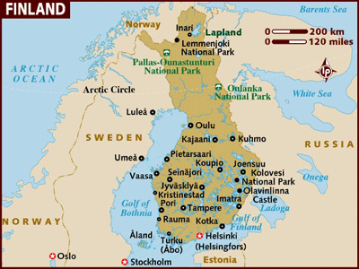

LOCATION :
Finland shares its borders with Sweden, Norway and Russia.
The Arctic Circle bisects the country beginning just north of where the Gulf of Bothnia closes up, with the city of Rovaniemi considered the gateway to the Arctic section of the country and Lapland, the home of the Northern Sámi people who continue a semi-nomadic life in the far north of the whole of the Nordic countries.

VISA: The visa is to be obtained prior to arrival in the country

HOW TO GET THERE :
International Airport : Helsinki International Airport.
Finnair has introduced direct flights to Helsinki.

GETTING AROUND :
AIR : A comprehensive and regular network of flights, operated largely by Finnair, is offered between Helsinki and all other major towns and cities throughout the country. The northernmost town to which you can fly is Ivalo in Lapland.

TRAIN : The national railway company of Finland is VR (Valtion Rautatiet): its trains are fast, reliable, clean and it prides itself on being able to offer several hundred train connections throughout Finland per day no matter what the varying Finnish weather manages to conjure up.
The most popular and frequent routes are those linking the southern cities of Helsinki, Turku and Tampere. It is, however, possible to travel to Lapland by train, with Rovaniemi as the main rail hub in the north. Trains are in four categories - the fast Pendolino "shuttle" services connect central station hubs, the larger Inter-city and Express trains cover long-distances and may be single or double-decked and the slow local services that serve regional stations.
There are three services between Finland and Russia daily - delineated by name rather than number. The Russian train "Tolstoi" runs between Helsinki and Moscow (14hrs) while "Sibelius" (Finnish) and "Repin" (Russian) run from the Finnish capital to Vyborg and on to St Petersburg (7hrs) once a day each. You should have the appropriate visas and identifiers if planning to enter Russia. The Russian trains are particularly good, displaying that strange mix of Soviet-style luxury.
Both Eurail and InterRail train passes are valid on trains in Finland and a Finnrail pass which is valid for unlimited travel on either 3, 5 or 10 separate days in any one month.

BOAT : There is a daily ferry service between both Helsinki and Stockholm (journey time 14hrs), and Turku and Stockholm (journey time 10-12hrs). Two companies offer both these services - Viking Line (Tel: +358 (0)9-12-351) and Silja Line (Tel: +358 (0)9-18-041). The ferries are huge and fairly luxurious, with plenty of entertainment offered throughout the journey.

DISTANCES :
The following table provides approximate driving distances between selected cities. Kilometres in the lower left of the table, miles in the upper right.

City | Hel | Tur | Tam | Ham | Por | Rov | Iva | Ina | St Pe
Helsinki | • | 103 | 108 | 62 | 31 | 506 | 684 | 707 | 240
Turku | 166 | • | 96 | 89 | 131 | 512 | 690 | 713 | 339
Tampere | 174 | 155 | • | 45 | 130 | 428 | 606 | 629 | 292
Hameenlinna | 101 | 144 | 73 | • | 85 | 452 | 630 | 653 | 221
Porvoo | 51 | 211 | 210 | 137 | • | 521 | 699 | 722 | 213
Rovaniemi | 815 | 825 | 690 | 728 | 839 | • | 177 | 200 | 579
Ivalo | 1101 | 1111 | 976 | 1014 | 1125 | 286 | • | 22 | 757
Inari | 1138 | 1148 | 1013 | 1051 | 1162 | 323 | 37 | • | 780
St Petersburg (Russia) | 387 | 547 | 471 | 357 | 343 | 933 | 1219 | 1256 | •

CURRENCY :
Official currency is Euro. 1 Euro = 100 Cents

BUISNESS :
Shops are generally open 10h00-20h00 Mon-Fri and 10h00-18h00 Sat. Most shops are closed on Sundays, though major department stores often open for some Sundays in summer time only, i.e, Jun, Jul and Aug.

CLIMATE :
June-August is Finland at its magical best, with long light-filled days and an endless expanse of unspoilt lakes and forests available as a massive playground for residents and visitors alike. The best weather normally follows the Midsummer period, with temperatures well up in the 20s and even 30s possible in July and August.

Midnight Sun and Northern Lights
Around Midsummer in northern Finland, the sun does not set for several weeks. In Utsjoki, for example, a single, long summer day lasts for over two months. Even in the south, the ’night’ consists of a period of prolonged twilight rather than real darkness.
The magical displays of shifting coloured light are strange and beautiful enough to transcend their scientific explanation, which says that the Northern Lights are caused by matter, or solar wind, from solar storms colliding with the Earth’s atmosphere.
When in Lapland you have a good chance of seeing the Northern Lights.The deep green and yellow colours, sometimes streaked with bands of red, are one of the most astonishing natural phenomena it is possible to witness. From November to January, various shades of soothing blue are Lapland’s most distinctive colours.During these mid-winter months, the sun does not rise at all.Te Northern Lights flash across the clear night skies. It’s possible to see the phenomenon in almost any part of Lapland - and sometimes much further south, including occasionally in Helsinki - if the weather conditions are right, but the best bet is in February-March and September-October in the Kilpisjärvi area in the far north of the country.

CLOTHING : Although with appropriate clothing you can visit Finland all year round, in practice most people come May-Sep. The warmest but also the wettest months. Make sure to take waterproof clothing, but also carry some lighter weight clothes. The far north is colder year round and specialist winter clothing is necessary if you plan on exploring this region through the winter months, although sensible clothing should be sufficient at other times.

TIME :
Finland is 4 hours behind India.

ELECTRICITY :
Electricity supply is 230 volts throughout Finland. A two-pin plug system, familiar throughout Europe, is used. Adapters are available in airport.

DIALLING CODE :
International dialling code: | 358
Area codes: | Helsinki: 9, Turku: 2, Lapland: 16, Oulu: 8, Vaasa: 6

TIPS :
Service charges are often included in restaurant bills and are factored into taxi bills. Consequently there is no need to make additional tips. If you choose to tip in the case of exceptional service then hand your donation directly to your server rather than adding it to the bill.

LANGUAGE :
Finnish and Swedish are the 2 official languages spoken in Spain. English and Sami are the other languages spoken.

INFORMATIVE WEBSITE :
www.visitfinland.com

CITIES :
HELSINKI :
Finland boasts a green and pleasant capital ideal for a city break or as a jumping off point for exploring the country's beautiful natural scenery. With Helsinki's location on a peninsula, wherever you go you won't be far from the sea and its southern position means that the city enjoys a milder climate than much of the rest of the country.

Accomodation Options in Helsinki :
Most accommodation in Helsinki tends to be fairly central, with a choice of quality hotels within a short distance of the city's major attractions. There are a number of hotels conveniently situated on and around the main streets of Pohjoisesplanadi and Mannerheimintie and around the central railway station.
Just a couple of minutes' walk from the station and adjacent to the botanical garden is the Arthur, offering good value for money considering its central location and comfortable accommodation.
A little further north en route to the airport, the Aurora is still within easy reach of central amenities while offering very Scandinavian-looking, modern décor and a good range of amenities including swimming pool and sauna.
For those who want a bit of sea air on their city break, there is a fair choice of hotels situated by the harbour or along the waterfront, which are still within easy reach of central facilities.

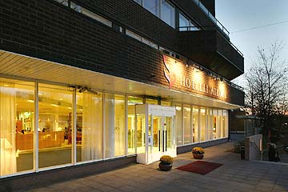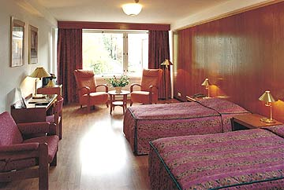

MUST-SEES :
Suomenlinna :
One of the most impressive sights in Helsinki is this huge 18th century military fort standing on a series of interconnecting islands directly opposite the city centre.
It first became a tourist attraction in the 1950s, to coincide with the Helsinki Olympic Games. Highlights of the islands include interesting historical museums, a number of open artists' studios (Suomenlinna is renowned for its creative talent) and an open-air theatre. There are also smaller museums, craft stores and several restaurants here, making it quite feasible to happily spend an entire day here. Special events, concerts and workshops are held daily. Though Suomenlinna gets busiest in the summer, it's a year-round attraction.
Visitor Centre and Suomenlinna Museum, Open: daily 10h00-18h00 (May-Sep), 10h00-16h00 (Oct-Apr). Other museum and attraction opening times vary. Admission to Suomenlinna Museum: EUR5. Suomenlinna Tourist Information, Tel: +358 (0)9-684-1880. Ferries and "water buses" travel between the island and Market Square daily.

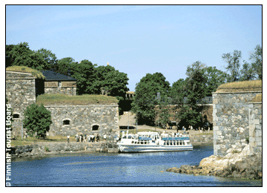

National Museum :
Easily recognisable thanks to its brick-coloured steeple that towers above the other buildings in the neighbourhood, the National Museum is a repository of Finnish artefacts and an ideal place to learn about traditional culture. Mannerheimintie 34. Open: Tue-Wed 11h00-20h00; Thu-Sun 11h00-18h00. Admission: EUR5.50, adults; free for children. Tel: +358 (0)9-4050-9544.
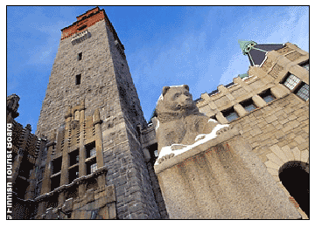

Sibelius Monument :
Finland's most famous composer and the creator of Finlandia has a monument dedicated to him in Sibelius Park. The controversial structure designed by Eila Hiltunen was the winner of a competition to create a memorial to the great musician, who died in 1957.
Unveiled in 1967, it was the subject of much debate as to its appropriateness due to its unusual concept and appearance. It's actually a collection of giant welded metal pipes that resemble super-sized windchimes. The wind sighing through the pipes makes music, of a sort. Visitors are welcome to walk underneath and among them. There's also a more conventional statue of the composer to keep the sceptics happy. The park setting is serene and picturesque, replete with photo opportunities and picnic spots.
Sibelius Park, Mechelininkatu 38, Taka-Töölö District. Open: daylight hours daily. Admission: free
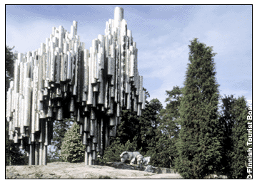

Market Square and Old Market Hall :
Experience a delightful combination of "olde worlde" charm and modern hustle and bustle at the central Market Square. Situated right on the harbour, this is the site for all kinds of action every day. In the morning, the day kicks off with an array of fish for sale while local farmers sell fresh produce from outdoor stalls. In the nearby market hall, vendors and crafts people purvey everything from smoked reindeer to handcrafted wooden ornaments.
The square serves as a central meeting point for Helsinki-ites and is flanked by the City Hall and other grand neoclassical municipal buildings. Ferries depart from here and several trams stop at various points around it.
Market, Helsinki Harbour. Open: Indoor market: Mon-Fri 08h00-19h00; Sat 08h00-16h00. Outdoor market: Mon-Fri 06h30-14h00; Sat 06h30-15h00; Sun 09h00-16h00 (Sun opening in summer only). Admission: free.
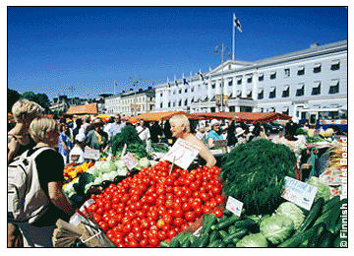

EXCURSIONS :
Seurassari :
The entire island of Seurasaari is dedicated to history. It is an open-air museum of Finland's heritage, with a community made up of traditional houses and buildings from the last three centuries. He took buildings piece by piece from the mainland and erected them here on an island just off the coast from the capital.
Predominantly agricultural, the centre of the community is the farmstead, where livestock and crops are reared in the traditional manner. Seurasaari contains complete farms from central and south-western regions of the country
Open: May & Sep: 09h00-15h00 Mon-Fri; 11h00-17h00 Sat-Sun. Jun, Jul & Aug: 11h00-17h00 daily, Wed until 19h00. Guided tours are conducted throughout the day in a variety of European languages. Admission: EUR5, adults; free, children. Tel: +358 (0)9-4050-9660.

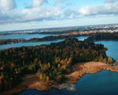
Poorvo :
Old Porvoo dates from the 14th century and is a favourite excursion from Helsinki. The second oldest city in Finland it was already an important trade centre by the time it was granted a royal charter in 1346.
The fortress that once protected this port town has disappeared, although evidence of its location can still be seen in the deep moats that remain. The old town centre, with its ochre-coloured chalet style houses, fronting on to the water, is particularly beautiful.
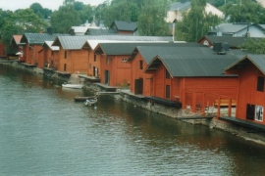

LAPLAND ROVANIEMI :
The Lapland Province extends from the northernmost shores of the Baltic in the south through forests that become gradually thinner as the terrain begins to rise in the north. The region remains home to a small population of indigenous Lapps or Same, and you can visit an excellent museum of their culture at Inari. The provincial capital and biggest city, Rovaniemi, sits on the Arctic Circle that dissects the area, and this is also where you’ll find the One True Home of Finland’s most popular resident: Santa Claus. The Santa Claus Village includes a post office which handles children’s letters to the Old Gentleman dispatched from all over the world, as well as the opportunity to meet Santa himself and have your photo taken with him in his grotto. There’s a SantaPark theme park nearby too.
Snowmobile, reindeer and dog-sled safaris take you into the valley forests and over the fells, and you can even spend the night in an igloo.

Travel connections:
Lapland is well-integrated into Finland's efficient road, rail and air networks, through which it has excellent domestic and international connections. Rail services - including overnight sleepers and car trains - run between Rovaniemi and Helsinki. International air traffic is operated directly, as well as via Helsinki and other Finnish towns, to Rovaniemi, Kittilä (near Levi), Enontekiö, Kemi and Ivalo. Airports are modern and equipped to facilitate extensive international traffic whatever the weather conditions.

ROVANIEMI :
The World Capital of Christmas and City on the Arctic Circle.

Must Sees :
Santa Claus Village :
As early as in the 1950’s Santa would often enjoy visiting the Arctic Circle near the town of Rovaniemi, not only on Christmas but all throughout the year, to visit both children and child-like. By 1985, his visits had become so regular that he founded his own village there. Today, his village includes Santa Claus’ Office and Santa Claus’ Main Post Office as well as the reindeer park nearby.
Santa Claus comes to the Santa Claus Village every day of the year to listen to children’s wishes and to talk to people from all over the world.

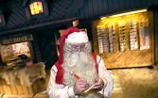

Unforgettable Nights of Snow And Ice
Have you ever wondered what it would feel like wrapping up in a warm sleeping back, sipping on a hot drink and dozing off to sweet dreams in a bedroom made of snow? Nice and cosy, funny and exciting, or just plain incredible? Come and experience it yourself in the Finnish Lapland!
People have slept in the snow for hundreds of years in the arctic areas in traditional snow shelters, such as igloos. Now you can do it in modern day style by staying at the breathtaking snow hotels of northern Finland.

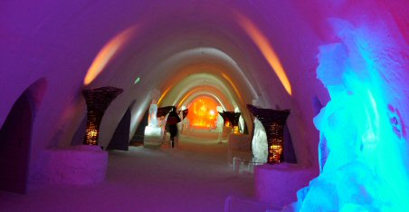

The Lainio SnowHotel in the western part of Finnish Lapland is located between two popular ski resorts, Ylläs and Levi, and only a 150-kilometre journey from the town of Rovaniemi, the SnowHotel is easy to reach. The Lainio SnowHotel opens 1 December every year. The nearest airport is Kittilä.
The Lainio SnowHotel offers nights in rooms with temperatures ranging between 0 and -5 degrees.
Sounds like a chill? Sleeping bags fit for arctic conditions guarantee that all guests will have an enjoyable night surrounded by pure white snow and ice. Decorations by local artists add to the atmosphere of the rooms.
Guests can also relax by a drink at the beautiful ice bar or sit down at the hot sauna, with the most courageous taking a dip in the icy water at an ice swimming spot.
The Lainio SnowHotel is part of the Lainio SnowVillage that offers a wide range of fun arctic activities, including husky rides. For those looking to start their marital life in unique surroundings, there’s a lovely chapel for the wedding ceremony on location and a honeymoon suite at the SnowHotel for one unforgettable wedding night.

Igloo Village Kakslauttanen
Igloo Village Kakslauttanen is located in Saariselkä (nearest airport is Ivalo). At Igloo Village Kakslauttanen you can have your pick of 20 igloos, including a honeymoon suite, for your stay.
For entertainment, enjoy a drink and a snack at the ice bar, visit the Ice Gallery for local art or throw the most memorable wedding or christening at the Ice Chapel.
The Igloo Village, located by the Hotel Kakslauttanen, is a prime spot for marvelling at the northern lights throughout the winter, thanks to little artificial lighting in the area and the Temple of Aurora Borealis, specially built for viewing the amazing natural phenomena.

The Mammut SnowHotel and the SnowCastle
The Mammut Snow Hotel in the SnowCastle of Kemi, on the northern coast of the Gulf of Bothnia, guarantees its guests a memorable experience in the coldness of an arctic night.
Temperature in the hotel rooms is approximately -5 degrees, but visitors will be warm and comfortable in sleeping bags designed for extreme conditions.
Choose from 29 double rooms, two rooms for groups of five people and a suite.
Both children and adults will enjoy the unique atmosphere and activities of the SnowCastle, such as the spectacular artwork of ice and snow, complete with lights and sound effects.
For entertainment, enjoy a drink and a snack at the ice bar, visit the Ice Gallery for local art or throw the most memorable wedding or christening at the Ice Chapel.
The Igloo Village, located by the Hotel Kakslauttanen, is a prime spot for marvelling at the northern lights throughout the winter, thanks to little artificial lighting in the area and the Temple of Aurora Borealis, specially built for viewing the amazing natural phenomena.

The Mammut SnowHotel and the SnowCastle
The Mammut Snow Hotel in the SnowCastle of Kemi, on the northern coast of the Gulf of Bothnia, guarantees its guests a memorable experience in the coldness of an arctic night.
Temperature in the hotel rooms is approximately -5 degrees, but visitors will be warm and comfortable in sleeping bags designed for extreme conditions.
Choose from 29 double rooms, two rooms for groups of five people and a suite.
Both children and adults will enjoy the unique atmosphere and activities of the SnowCastle, such as the spectacular artwork of ice and snow, complete with lights and sound effects.

Harriniva
The Harriniva resort in Muonio, Lapland (closest airport is Kittilä)offers a range of winter accommodation, including overnight stays at igloos.
Outside the temperature will regularly drop to -30, while guests in the igloos snuggle up in sleeping bags and reindeer skins.

SHOPPING :
Finland is not a destination for shopaholics, and if you're looking to spend your holidays searching the stores then you'll miss the best part of the country - it doesn't lie on its shopping streets. Having said that Helsinki is a pleasant enough place to browse, while the markets of Tampere are justly renowned, as is Finland's oldest market - Turku's famous Kauppa Halli on which all Finnish markets are modelled. All in all, it shouldn't be too difficult to pick up a few distinctive items that make superb gifts and souvenirs of a trip here.
What to Buy ;
It's possible to find a wide range of gifts and souvenirs that are unique to Finland. Glassware is a Finnish speciality and all department stores carry a wide range of glass items by such companies as Iittala, Nuutajarui and Arabia. Helsinki's Stockmann department store is one such outlet for glassware although gift shops all over the country will stock pieces from all the big names. Fashion tends to veer towards plain designs, but they are always elegantly made.
Notably traditional Sámi handicrafts always capture the eye of tourists. These include jewellery made from reindeer bone, colourful waistcoats and wall hangings covered in arctic foxes or the blazing midnight sun. Also look out for the carved birchwood cups called 'kuksas' - ideal for a toast or two when you get home.
Genuine Sámi handicrafts bear a 'duodji' label and although the largest selection is to be found in the Lapland village of Inari, it's possible to buy items at outlets throughout Helsinki and other major cities. In Inari, the Sámi Duodjar Centre sells crafts made from all-natural materials by some 70 local artisans and is well worth visiting. You should also check out Samekki, the studio of Petteri Laiti, the most famous Sámi artisan of all. His studio shop offers a range of products made from reindeer antlers and hide, gnarled wood, silver and gold. CDs featuring traditional Finnish music, such as Sámi 'yoiks', a traditional form of throat singing, are also available at outlets in Lapland and Helsinki, although the distinctive sound might not be the music you want in your car on your return home.
Finland is well-known, too, for its hand-knitted woollens such as sweaters, gloves, hats and scarves and these are available for purchase throughout the country. Finnish fur and leather is as high quality as you'll find anywhere. Also, Finnish traditional/rustic fashions have begun to make a comeback among local fashion designers such as Marimekko. This style, which also can be loosely translated as "wilderness" is incorporated into many Helsinki designers' latest collections.
INDIAN RESTAURANTS :
Helsinki

Maharaja
Mannerheimintie 21 - 23
Helsinki
Phone: +358 9 444436
www.ravintolaopas.net/maharaja
Namaskaar
Mannerheimintie 100
Helsinki
Phone: +358 9 4771960
www.ravintolaopas.net/namaskaar

Namaskaar-Bulevardi
Bulevardi 6
Helsinki
Phone: +358 9 6220155
www.ravintolaopas.net/namaskaarbulevardi
Namaskaar & Wok It
Sanomatalo/Postikuja 2
Helsinki
Phone: +358 9 68121450
www.ravintolaopas.net/namaskaarwokit

Namaskaar Express
Aleksanterinkatu 36 B
Helsinki
Phone: +358 9 2781363
www.ravintolaopas.net/namaskaarexpress

Samrat
Eteläesplanadi 22
Helsinki
Phone: +358 9 611 001
www.samrat.fi

Sandeep
Lönnrotinkatu 22
Helsinki
Phone: +358 9 685 6206

Shalimar
Mannerheimintie 160
Helsinki
Phone: +358 9 4369 2706
www.shalimarclub.com

